**Failover routing Route 53**

**Create 3 instance**

**Instance 1 --Primary Instance (index.html)**

**Instance 2- secondary Instance(index.html)**

**Instance 3-Just to test the task**

**Route53---Create private hosted zone (india.ust.com)**

**>> A record -Primary ( tvm.india.ust.com)**

**TTL mini**

**Ip Address**

**Routing Policy ---Failover routing**

**Health Check**

**>> A record -secondary**

**TTL mini**

**Ip Address**

**Routing Policy ---Failover routing**

**Health Check**

**SSh to Instance3 ----->curl tvm.india.ust.com**

**To Test u stop the primary instance**

**curl tvm.india.ust.com**

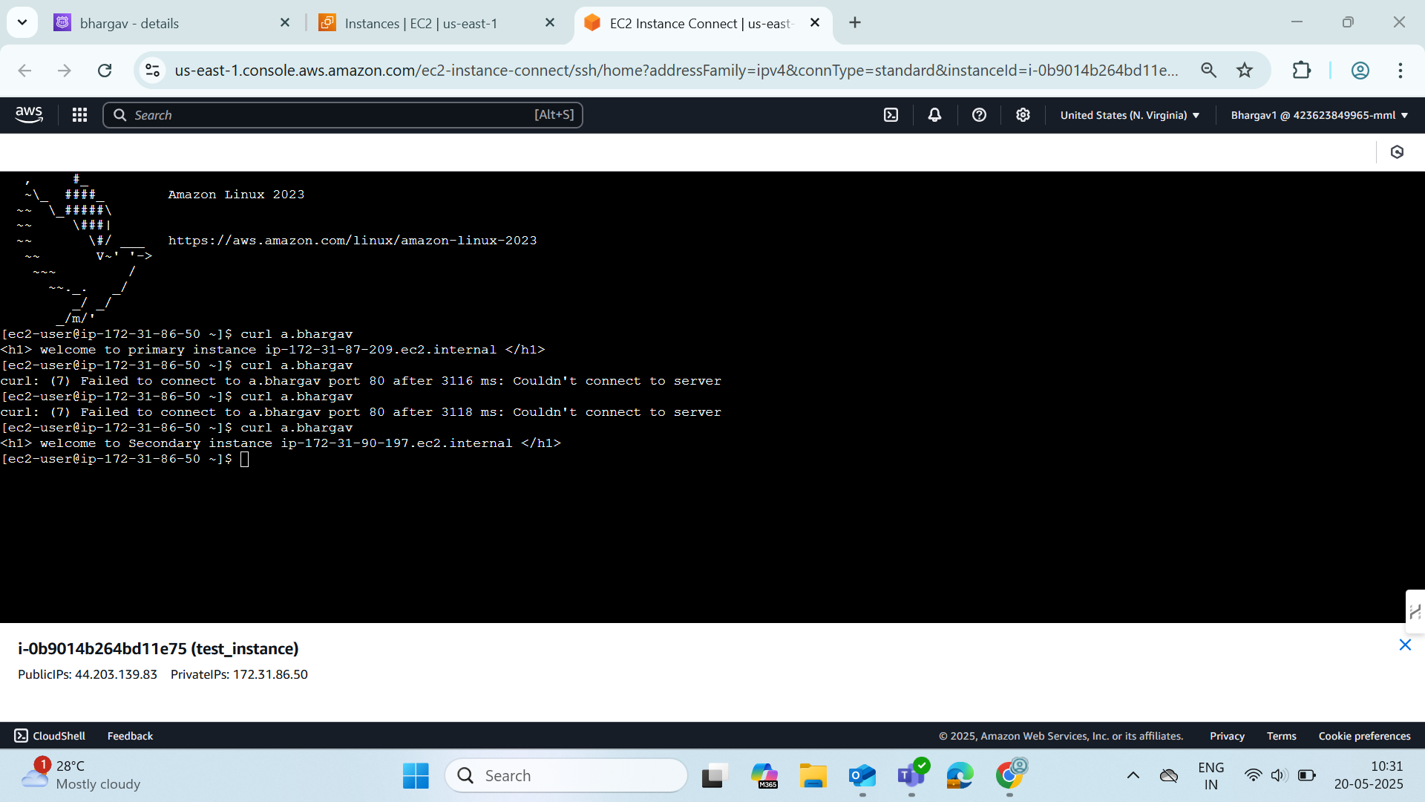

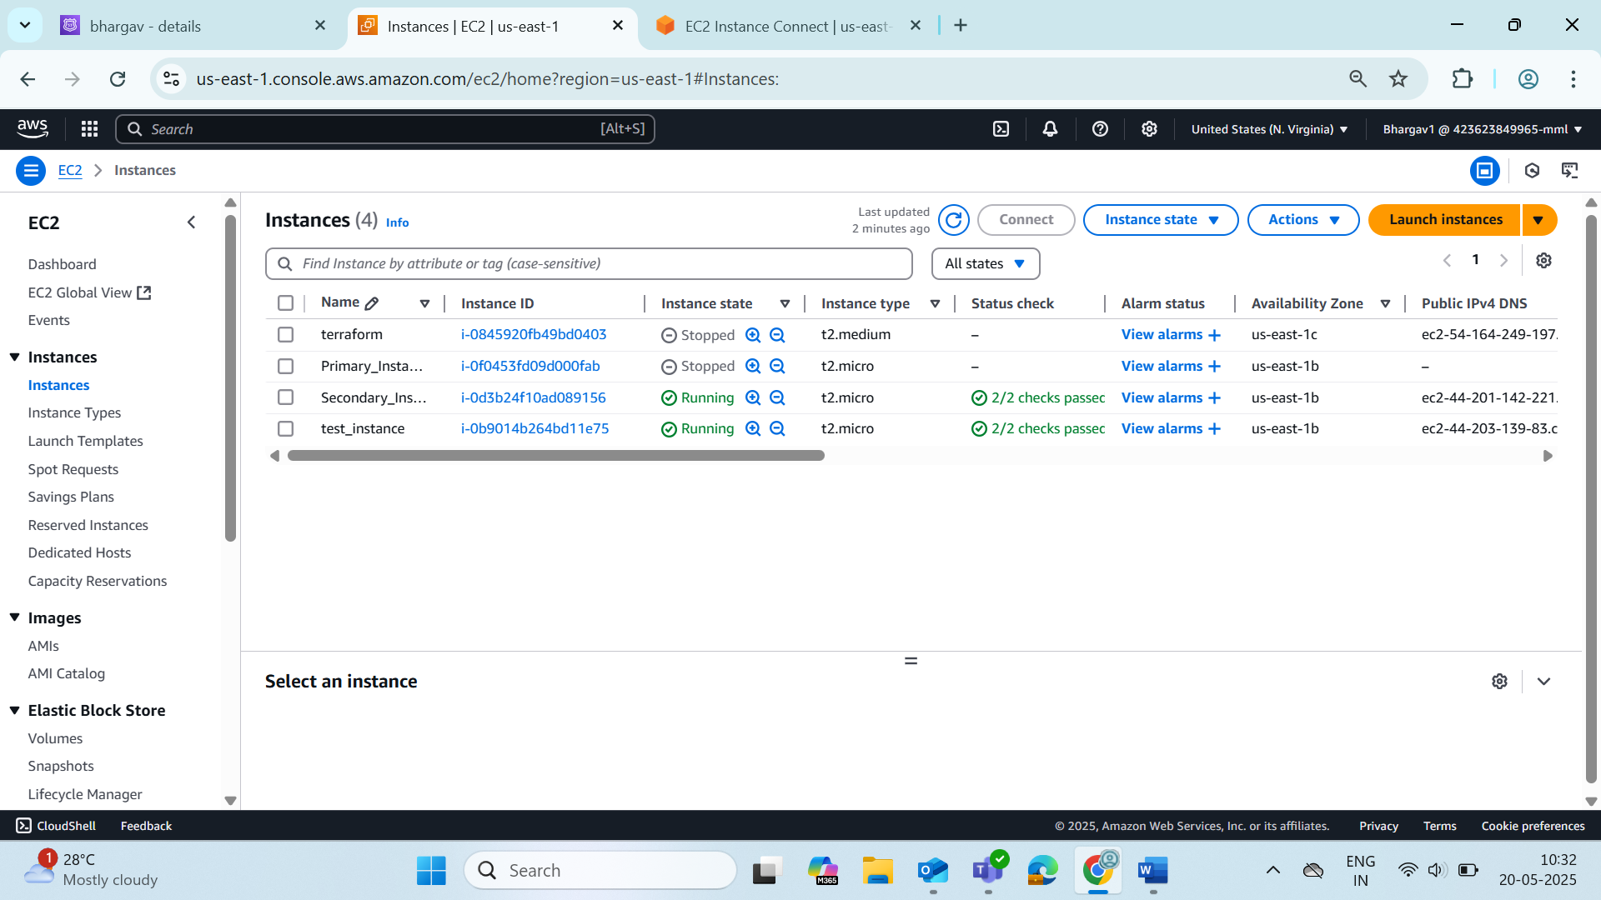

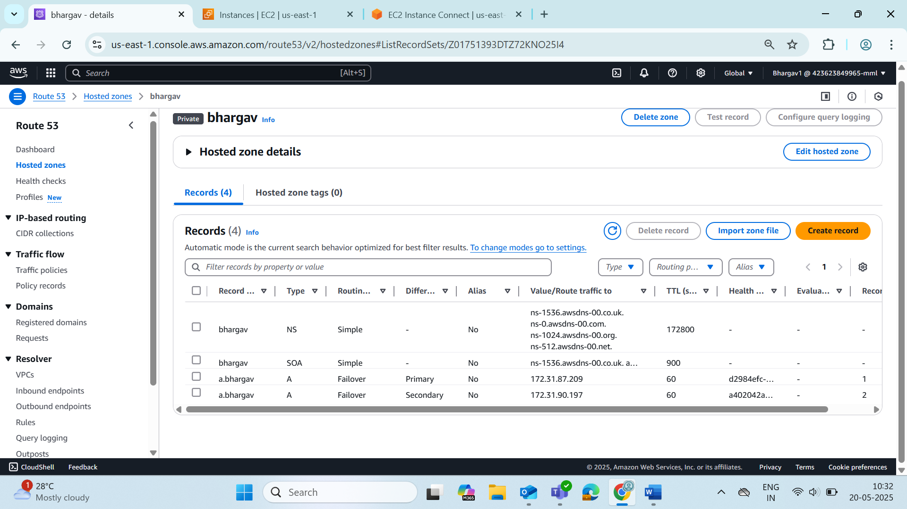

Instance1 is unhealthy because I stopped it for testing

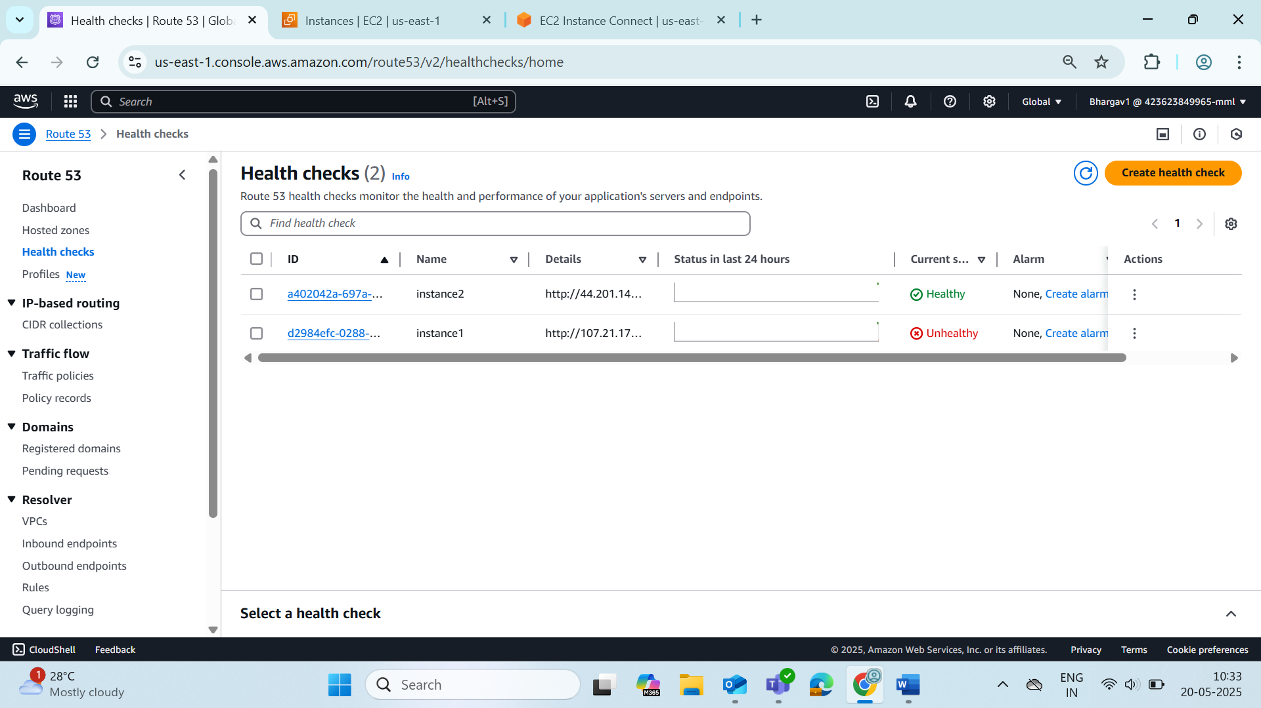

**Elastic Beanstalk(zip file in dowmloads)(nodejs)**

